IALA Recommendation xxx

Annex x

Inter System

Track Data Exchange Services

Revision

# | Date | Description | Initials
V 0.1 | 14.04.2008 | Version 0.1, Rev1 | GJ
V.0.2 | 14.04.2008 | Version 0.2, Rev2 | GJ
V.0.3 | 18.04.2008 | Version 0.2, Rev3 | GJ
V.04 | 23.10.2008 | Version 0.2, Rev4 | GJ

Table of Contents

Introduction

This Annex XX expands on the Service Model description of Inter (VTS) System Track Data Exchange (TDE) Service related to Interfacing Model within the ‘e-Nav service engineering models’, with reference in document ‘31_DraftNewRecOnGenericE-NavServiceModel_ENav-210_V1.01.doc.’ The document will be modified referring data objects, elements and types to the ‘IALA recommendation XX- Universal Maritime Data Model’ (The Universal Maritime Data Model – IALA part: e-Nav 0220 – 0249).

< Inter System Track Data Exchange Service>
General
Service Model
- Annex 1 Track Exchange Services = 81d
- Annex 2 Distribution Model (ref WD-A124-A02) = 81e
- Annex 4 XML Interface Control Model of Track Exchange = 81c (ICD)
- Annex 5 XML Data Format of Track Exchange = 81b (IVEF)
- Annex 8 Test Model for of Track Exchange = = 81f

Design Considerations
Management
Implementation, Installation, and Maintenance
Functional Components of Track Exchange

Each TDE supports an interaction between E-Nav Services.

The justification for this annex is to describe the interface of TDE to be used for user purposes like Human Machine Interface (HMI) including presentation on Traffic Display. The TDE developed as a consequence of the IMO Performance Standards for Track Data exchange. Tracks can be related to sea, air and shore objects like vessels, AtoN, helicopters (SAR) or VTS, derived from AIS basic services (BAS) or other means (radar tracking, LRIT, VTS generated,… ). Position, static, voyage related and safety related data of the object can be included according to availability.

The TDE are categorized into "external" and "internal". The "external" TDE are those TDE which deliver information within dedicated eNAV system. External TDE are the interface between different eNAV system.

Reference

As defined by < Inter System Track Data Exchange Service>and in addition:

Definitions

The term object will be used for vessels, AtoN and helicopters (SAR).

As defined by < Inter System Track Data Exchange Service>and in addition:

Abbreviations

As defined by < Inter System Track Data Exchange Service>and in addition:

General

Part I: Primary service use cases of the TDE Service

General

Primary service use cases of the TDE Service
The most important features are the primary use cases of the TDE Service. The primary service use cases all have in common, that they are justified by at least one interaction with a “requesting service” within the common eNAV system architecture: The “requesting service” is any other service of the common eNAV system architecture putting a request (logon) to the TDE Service as indicated in the previous chapter.

The primary service use cases of the TDE Service as derived by the above use case derivation process are called external TDE Services (TDE). Therefore, it is the external TDE, which genuinely treat the TDE data. However, there might be additional primary use cases required, namely e.g. replay functionality.

Figure A provides an overview on all primary service use cases of the TDE Service.

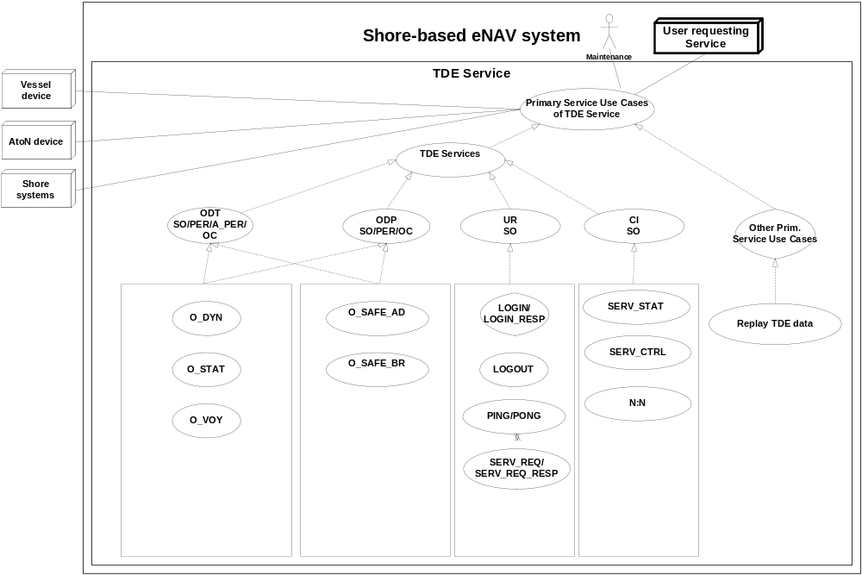Note: The dotted lines indicate inheritance relationship.
Figure A: Complete overview on primary service use cases of the TDE Service

The complete list of external TDE Services and their categories is given below:

- TDE Service Data Category:

- CI: Control Information
- UR: User Request
- ODT: Object (Vessel/AtoN/SAR) Data Track
- ODP: Object (Vessel) Data Planned

- TDE Transmission Category

- SO: Single occurrence (non-realtime)
- PER: Periodic, with a specified update rate (real-time)
- A-PER: A-periodic, synchronous with the received track update (real-time)
- OC: On change, updates are sent as data element change

- TDE Basic Service Data Elements:

- LOGIN:
- LOGIN_RESP:
- LOGOUT:
- PING:
- PONG:
- SERV_REQ: Service request (category, area)
- SERV_REQ_RESP: Service request response
- SERV_STATUS: Service Status
- TDE_CTRL: Service control
- SERV_STATUS: Service Status
- O_DYN: Object position report (ref. AIS message 1,2,3 )
- O_STAT: Object static data (ref. AIS message 5)
- O_VOY: Object voyage related data (AIS message 5)
- O_SAFE_AD: Object addressed safety related data (ref. AIS message 12)
- O_SAFE_BR: Object broadcast safety related data (ref. AIS message 14)

    - Service Name: O_STAT: Static ship data

Service Overview

The O_STAT provides the following static information between E-Nav Services of the object according to aviability. This information is derived from the AIS Class A/B mobile station broadcast of ITU 1371 Message 5, similar sources or user input (VTS/DataBase).

-Length
-Width
-Call Sign
-Name
-Type
-IMO Number
-MMSI Number
-Source type of O_STAT
-AtoN type
-AtoN name
-AtoN Off Position
-Native Language Ship Name
-Port of Registry
-Country Flag
-Maximum Air Draught
-Maximum Draught
-Route Bounded

Service Model:
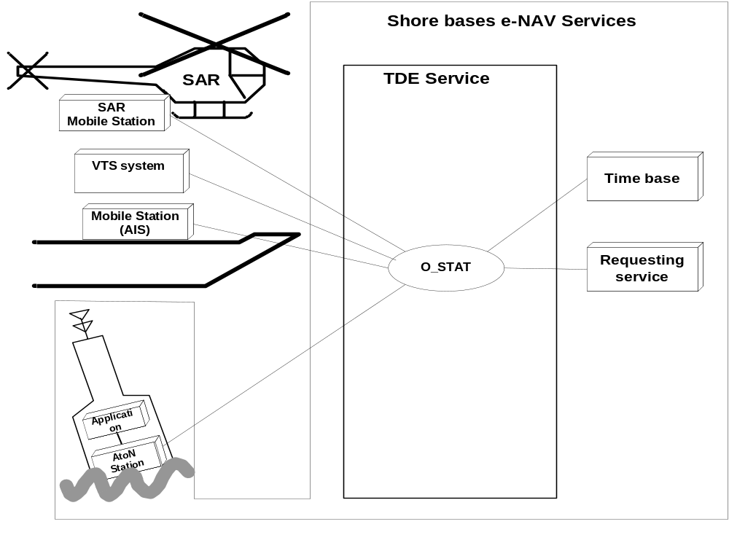

Figure 1: O_STAT:

Use
-The static ship information is used to identify and classify ships.
-The ship's dimensions are important in order to determine and evaluate the maneuvers of
a ship.
-The details regarding the ship's position sensor are important in order to assess the
accuracy of the position information.

Risks

-The static information is entered manually on ship or VTS system and it is possible that
this data may be faulty;
-The limited precision of the ship's dimensions and the location of the position sensor
have to be taken into consideration when evaluating this data

Service Data Structure

Required | Field Name | Field  Type | Field Resolution | Description
 | E-Nav Service | integer | x | TDE
 | Time Tag | ISO 8601 UTC |  | Sent time  (YYYY-MM-DDThh:mm:ss.sss)
 | Object ID | integer |  | Unique Id of object (track)  within Service
 | Source ID | integer |  | Unique Id of Service
 | Basic E-Nav Service | integer | x | O_STAT
 | Length | decimal | x.x | Derived from the Overall dimensions of the ship
 | Width | decimal | x.x | Derived from the Overall dimensions of the ship
 | Call Sign | string |  | @@@@@@ = not available
 | Name | string |  | @@@... = not available
 | Type | integer | xxx | Derived from Type of Ship (exclude cargo) ref ITU1371:  20 = WIG  30 = fishing vessel  31 = towing vessel  32 = big towing vessel  33 = dregging vessel  34 = diving vessel  35 = military vessel  36 = sailing vessel  37 = pleasure craft  40 = HSC  50 = pilot vessel  51 = SAR  52 = tug  53 = port tender  54 = anti pollution vessel  55 = law enforcement vessel  58 = medical vessel  59 = mob83 vessel  60 = passenger ship  70 = cargo ship  80 = tanker  90 = other ship type
 | IMO Number | string |  | IMO Unique Identifier
 | MMSI Number | string |  | ITU Unique Identifier
 | Source type | integer |  | Transponder, DataBase, Direct User
 | AtoN type | integer | x
 | AtoN name | string
 | AtoN Off Position | string | xx
 | Native Language Ship Name | string
 | Port of Registry | string
 | Country Flag | string
 | Maximum Air Draught | decimal | xxx.x | From Object Construction
 | Maximum Draught | decimal | xx.x | From Object Construction
 | Route Bounded | string |  | Bounded to a sailing route or navigational channel

Operating Characteristics

- The TDE shall start automatically upon logon confirmation
- For AIS BAS, the data will be broadcast every 6 minutes.
- The data will be sent depending on transmission category

    - Service Name: O_DYN: Dynamic ship data

Service Overview

The O_DYN provides the following dynamic information between E-Nav Services. This information is derived from the AIS Class A mobile station broadcast of ITU 1371 Message 1, 2 and 3, broadcast at a variable rate based upon speed and maneuvering status of ship, or from radar tracking system or other sensors (VHF-DF,…).

- Latitude
- Longitude
- Update Time of position determination
- Accuracy of the position
- Speed over ground (SOG)
- Course over ground (COG)
- Tracking Status (terminated)
- Tracking Phase (optional)
- Rate of turn (ROT) (if available)
- Navigational status
- Orientation (heading)
- Measured length
- Measured width
- Altitude
- Type of position sensors

Service Model:
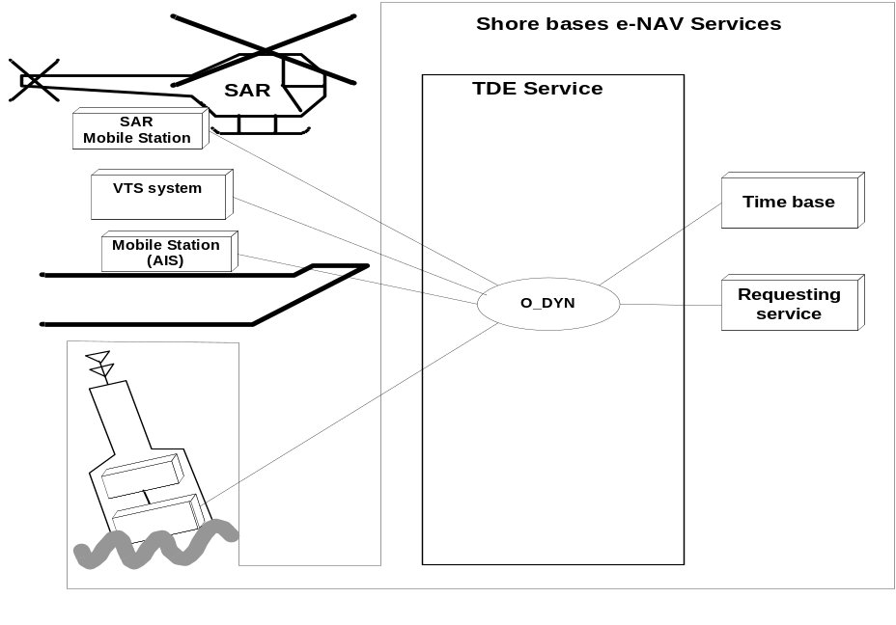
Figure 2: O_DYN

Use:
The dynamic information combined with the data derived from O_STAT (Static information) and O_VOY (Voyage Information) can be used to visualize the traffic situation.

Risks:
This data is only as accurate as the sensor data provided autonomously and automatically to the AIS-station from shipboard AIS transponder or radar sensors, or from shore radar of a VTS system.

Service Data Structure

Required | Field Name | Field Type | Field Resolution | Description
 | E-Nav Service | integer | x | TDE
 | Time Tag | ISO 8601 UTC |  | Sent time  (YYYY-MM-DDThh:mm:ss.sss)
 | Object ID | integer |  | Unique Id of object (track) within Service
 | Source ID | integer |  | Unique Id of Service
 | Basic E-Nav Service | integer |  | O_DYN
 | Latitude | decimal | xx.xxxx | Latitude of object gravity centre ref datum WGS84 (+/- 90 degrees; North = positive; South = negative)
 | Longitude | decimal | xxx.xxxx | Longitude of object gravity centre ref datum WGS84 (+/- 180 degrees; East = positive; West = negative)
 | Update Time tag of position determination | ISO 8601 UTC |  | (YYYY-MM-DDThh:mm:ss.sss)
 | Accuracy of the position | decimal | xxxxx.x | The position accuracy in meter corresponding to 1 sigma assuming normal distribution
 | Speed over ground | decimal | xxx.x | Speed over grounding in m/s
 | Course over ground | decimal | xxx.x | Course over ground in degrees 0-359.9
 | Tracking Status | string |  | Updated, Coasted, Terminated
 | Tracking Phase | string |  | Application defined:  Detection, Stable, Lost
 | Rate of turn | decimal | x.xxx | Rate of turn in degrees per minute
 | Navigational status | integer | xx | Derived from Navigational status  0 = under way using engine,  1 = at anchor,  2 = not under command,  3 = restricted maneuverability,  4 = constrained by her draught,  5 = moored,  6 = aground,  7 = engaged in fishing,  8 = under way sailing,  9 = reserved for future amendment of navigational status for ships carrying DG, HS, or MP, or IMO hazard or pollutant category C (HSC),  10 = reserved for future amendment of navigational status for ships carrying DG, HS or MP, or IMO hazard or pollutant category A (WIG);  11-14 = reserved for future use,  15 = not defined = default
 | Orientation (Heading) | decimal | xxx.x | Degrees 0-359.9
 | Measured length | decimal | x.x | From actual sensor (radar) in meter
 | Measured width | decimal | x.x | From actual sensor (radar) in meter
 | Altitude | decimal | xxxxx.x | The reported altitude of the target from AIS (SAR) in meters above sea level
 | Type of position sensors | integer | mnop | {m,n,o,p} =  1 = radar  2 = ais  3 = Loran C  4 = VHF-DF  5 = LRIT  6 = Synthetic (User generated),  9 = other  {m,n,..}<> 0: multitracked

Operational Characteristics
- The TDE shall start automatically upon logon confirmation
- The data will be sent depending on transmission category

    - Service Name: O_VOY: Voyage related ship data stations

Service Overview
The O_VOY provides the following voyage related information between E-Nav Services. This information is derived from the AIS Class A/B mobile station broadcast of ITU 1371 Message 5 or similar sources or user input (VTS/DataBase);

-Maximum present static draught
-Type of Cargo
-Destination
-ETA
-Source type of O_VOY
-Actual time of arrival (ATA)

Service Model:

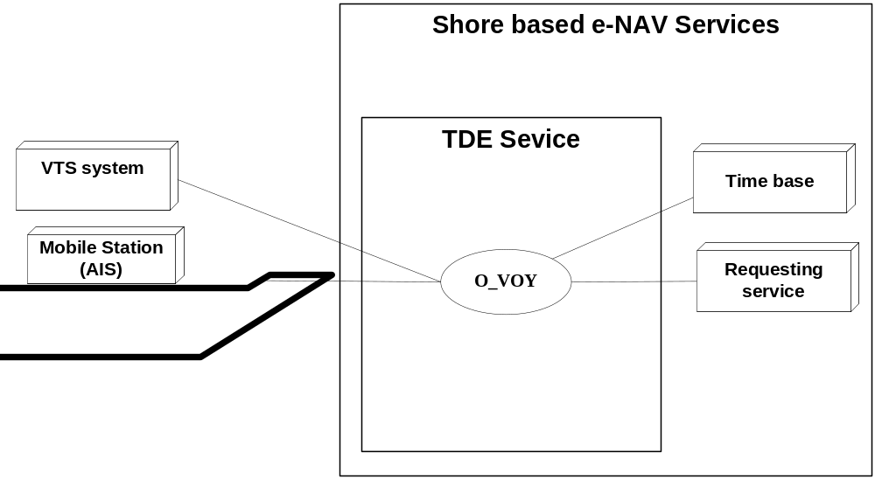
Figure 3: O_VOY

Use:
-The voyage related ship information is used to classify ships regarding cargo, draught and routes.
-The ship's destination is important in order to determine the route of a ship. It is recommended to use the UN/LOCODE in the destination field.

Risks

-The static information is entered manually on ship or VTS system and it is possible that
this data may be faulty;

-The voyage related information is entered manually before the voyage on ship or VTS
system and it is possible that this data may be faulty;
-Information on the type of cargo provides only the classification of dangerous goods
(Carrying DG, HS, or MP, IMO hazard or pollutant category A, B, C, D)

Service Data Structure
Required | Field Name | Field  Type | Field Resolution | Description
 | E-Nav Service | Integer | x | TDE
 | Time Tag | ISO 8601 UTC |  | Sent time  (YYYY-MM-DDThh:mm:ss.sss)
 | Object ID | Integer |  | Unique Id of object (track)
 | Source ID | Integer |  | Unique Id of Service
 | Basic E-Nav Service | Integer |  | O_VOY
 | Maximum present static draught | Integer | xx.x | Planned for this voyage
 | Type of Cargo | Integer | xx | Derived from Type of Ship and Cargo Type (exclude ship type  ):  0 = All ships of this type  1 = Carrying DG, HS, or MP, IMO hazard or pollutant category A  2 = Carrying DG, HS, or MP, IMO hazard or pollutant category B  3 = Carrying DG, HS, or MP, IMO hazard or pollutant category C  4 = Carrying DG, HS, or MP, IMO hazard or pollutant category D  9 = No additional information
 | Destination | String |  | @@@... = not available
 | ETA | ISO 8601 UTC |  | Estimated time of arrival;  (YYYY-MM-DDThh:mm:ss.sss)
 | Source type | integer |  | 1 = transponder  2 = database  3 = manual
 | ATA | ISO 8601 UTC |  | Actual time of arrival; (YYYY-MM-DDThh:mm:ss.sss)

Operational Characteristics

- The TDE shall start automatically upon logon confirmation
- For AIS BAS, the data will be broadcast every 6 minutes.
- The data will be sent depending on transmission category

    - Service Name: O_SAFE_AD Safety related addressed message

Service Overview

This TDE provides a means for the E-Nav Services to transfer addressed safety related information detected between AIS-BAS Services.

When an E-Nav Service is addressed in a Message 12 the TDE will provide the following information to the E-Nav Service

- Own object sending
- MMSI of addressed/transmitting AIS station or E-Nav Service
- MMSI of addressed/received AIS station or E-Nav Service
- ASCII text of the safety related information

Service Model:
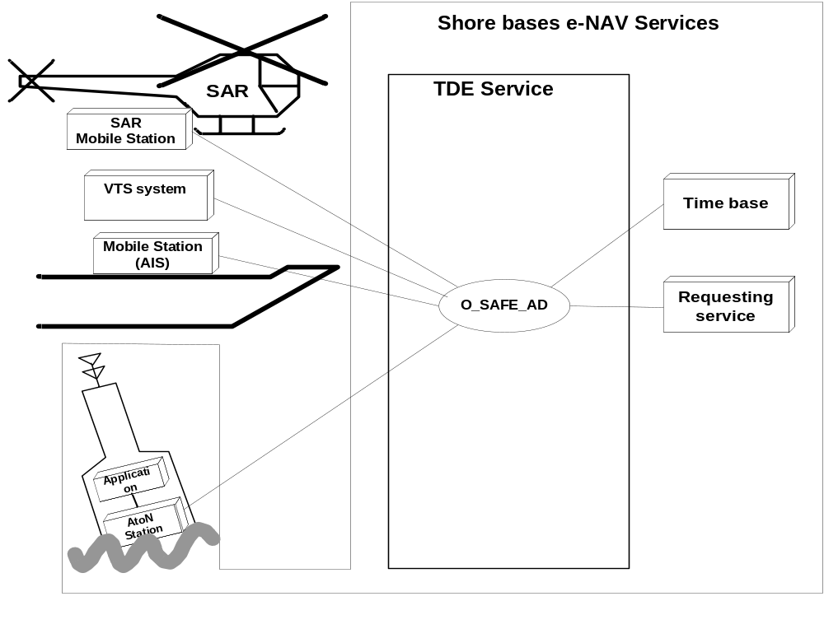
Figure 4: O_SAFE_AD

Use

- This TDE will facilitate the transmission of safety related messages from shore to shore.
- The TDE shall start automatically upon logon confirmation

Service Data Structure

Required | Field Name | Number of Characters | Field Type as define by IEC 61162-1 | Description
 | E-Nav Service | integer | x | TDE
 | Time Tag | ISO 8601 UTC |  | Sent time  (YYYY-MM-DDThh:mm:ss.sss)
 | Object ID | integer |  | Unique Id of object (track)
 | Source ID | integer |  | Unique Id of Service
 | Basic E-Nav Service | integer |  | O_SAFE_AD
 | Direction | integer |  | 1: sending, 2: receiving,
 | Source ID | integer |  | MMSI of the source of the message (possibly own)
 | Destination ID | integer |  | MMSI of the destination of the message
 | ASCII text field | string

    - Service Name: O_SAFE_BR: Safety related broadcast message

Service Overview

This TDE provides a means for the E-Nav Services to transfer broadcast (not addressed) safety related information detected between AIS-BAS Services.

When an E-Nav Service receives a Message 14 the TDE will provide the following information to the E-Nav Service:

-
MMSI of sending AIS station or E-Nav Service
- ASCII text of the safety related information

Service Model:
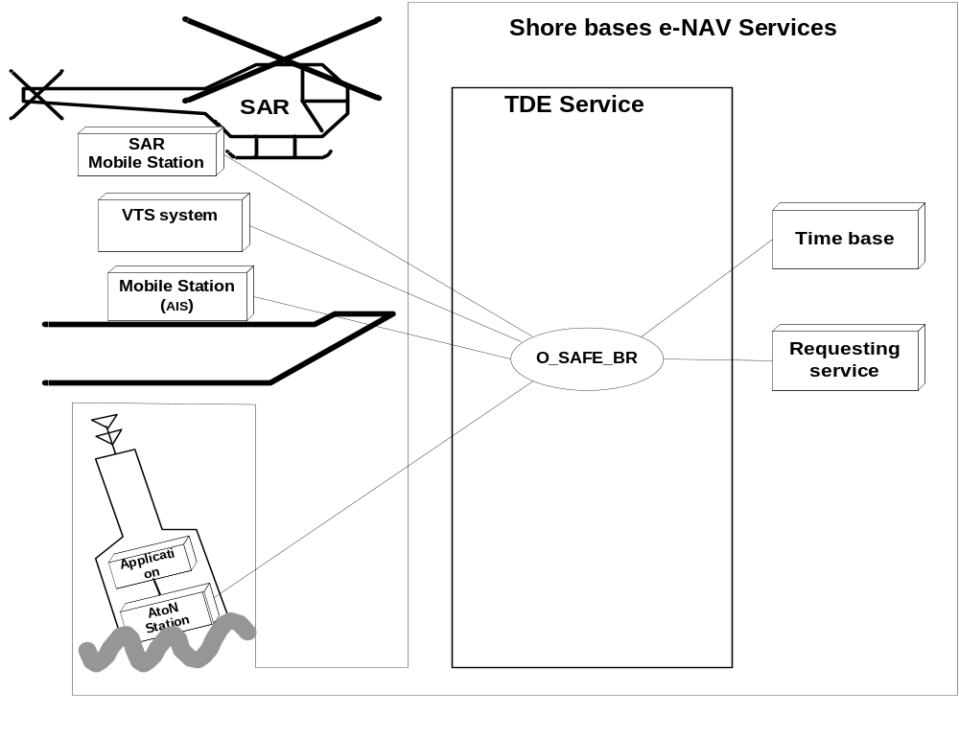
Figure 5: O_ SAFE_BR

Use
- This TDE will facilitate the transmission of safety related messages from shore to shore.
- The TDE shall start automatically upon logon confirmation

Service Data Structure

Required | Field Name | Field  Type | Field Resolution | Description
 | E-Nav Service | integer | x | TDE
 | Time Tag | ISO 8601 UTC |  | Sent time  (YYYY-MM-DDThh:mm:ss.sss)
 | Object ID | integer |  | Unique Id of object (track)
 | Source ID | integer |  | Unique Id of Service
 | Basic E-Nav Service | integer |  | O_SAFE_BR
 | Source ID | integer |  | >0: MMSI of the sending object of the message (possibly own)
 | ASCII text field | string

Part III: Tertiary service use cases of the TDE Service
Tertiary service use cases only treat faulty conditions or constitute optimizations while not changing functionality in substance.

SYSTEM LEVEL REQUIREMENTS
SPECIAL CONSIDERATIONS

Relationship of this functional block to the other functional blocks (pictorial)
Interfaces (logical/physical) to other functional block to the other functional blocks
Functional Description
Requirements to Other Components
Special Considerations

